**ERP System Implementation for Averx Water Manufacturing and Distribution Company**

**1.0 Introduction**

This document outlines the design of an ERP (Enterprise Resource Planning) system specifically tailored for Averx, a company engaged in both water manufacturing and distribution. The primary goal of this ERP system is to integrate various business functions into a cohesive framework that enhances operational efficiency, optimizes workflows, and supports data-driven decision-making throughout the organization.

**2.0 System Architecture**

The ERP system for Averx will adopt a modular architecture, allowing the company to implement specific functionalities as needed while maintaining the option for future expansion. Each module will correspond to a core business function, ensuring that data flows seamlessly between them for improved process integration.

**2.1 Modules Overview**

2.1.1 Inventory Management

2.1.2 Production Planning and Control

2.1.3 Sales and Order Processing

2.1.4 Purchasing and Supplier Management

2.1.5 Finance and Accounting

2.1.6 Human Resources Management

2.1.7 Reporting and Analytics

**2.2 Technology Stack**

**Frontend:** React.js will be utilized to create a dynamic and responsive user interface that enhances user experience.

**Backend**: Node.js with Express.js will handle server-side logic, providing a robust environment for application development.

**Database:** PostgreSQL will serve as the relational database, ensuring efficient data storage and retrieval.

**API**: RESTful APIs will facilitate integration with third-party applications and existing systems, promoting interoperability.

**Security**: JSON Web Tokens (JWT) will be employed for secure user authentication, while Transport Layer Security (TLS) will ensure data encryption during transmission.

**Hosting**: AWS EC2 will provide scalable and reliable cloud hosting, allowing for flexibility in resource allocation based on demand.

**3. Modules and Functionalities**

**3.1 Inventory Management**

The Inventory Management module will be crucial for maintaining optimal stock levels and ensuring that production runs smoothly.

**Stock Tracking**: This feature will enable Averx to monitor the quantities of raw materials, work-in-progress items, and finished goods in real-time. By keeping accurate records of inventory levels, the company can prevent stockouts and overstock situations.

**Automatic Reorder**: The system will allow users to set reorder levels for essential raw materials. When stock levels fall below these thresholds, the system will automatically generate purchase orders, ensuring that necessary materials are always available for production.

**Batch Management**: This functionality will track production batches, which is essential for quality control and compliance with safety regulations. In case of a product recall, the system will facilitate the identification of affected batches.

**Reporting**: Users will have access to comprehensive reports on inventory turnover rates, stock levels, and valuation, enabling better inventory management decisions.

**3.2 Production Planning and Control**

This module will focus on optimizing the manufacturing process to meet demand efficiently.

**Production Scheduling**:

The system will allow Averx to plan and schedule production runs based on demand forecasts and current inventory levels. This will help in minimizing downtime and maximizing resource utilization.

**Resource Allocation**:

The module will facilitate the allocation of labor, machinery, and raw materials, ensuring that production processes are efficient and cost-effective.

**Quality Control**:

Implementing quality checks at various stages of production will help maintain high product standards. The system will allow for documentation of quality assessments and corrective actions taken.

**Production Reporting**:

Users will be able to monitor production efficiency, track downtime, and analyze yield rates, providing insights into areas for improvement.

**3.3 Sales and Order Processing**

This module will streamline the sales process, from order receipt to fulfillment.

**Order Management:**

The system will track customer orders throughout their lifecycle, ensuring timely fulfillment and accurate record-keeping.

**Pricing Management:**

Averx will be able to manage pricing structures, discounts, and promotional offers effectively, allowing for competitive pricing strategies.

**Invoicing:**

The system will automate the invoicing process, generating and sending invoices to customers upon order fulfillment, which will improve cash flow management.

**Customer Relationship Management (CRM):**

This feature will allow Averx to track customer interactions, manage contacts, and analyze sales performance, fostering better customer relationships and targeted marketing efforts.

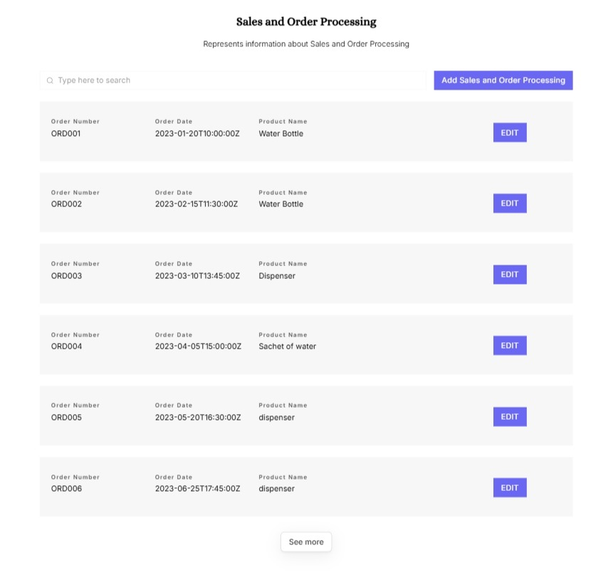

**3.4 Purchasing and Supplier Management**

Effective supplier management is critical for maintaining a smooth supply chain.

**Supplier Database:**

The system will maintain a comprehensive database of approved suppliers, including contact details, lead times, and payment terms, facilitating better supplier relationships.

**Purchase Order Management:**

Users will be able to generate and track purchase orders, manage approvals, and monitor delivery schedules, ensuring that materials are received on time

**Supplier Performance Evaluation:**

The module will enable Averx to assess supplier performance based on criteria such as delivery times, product quality, and cost-effectiveness, supporting informed sourcing decisions.

Integration with Inventory: The system will automatically update inventory levels upon receipt of goods, ensuring that stock records are always accurate.

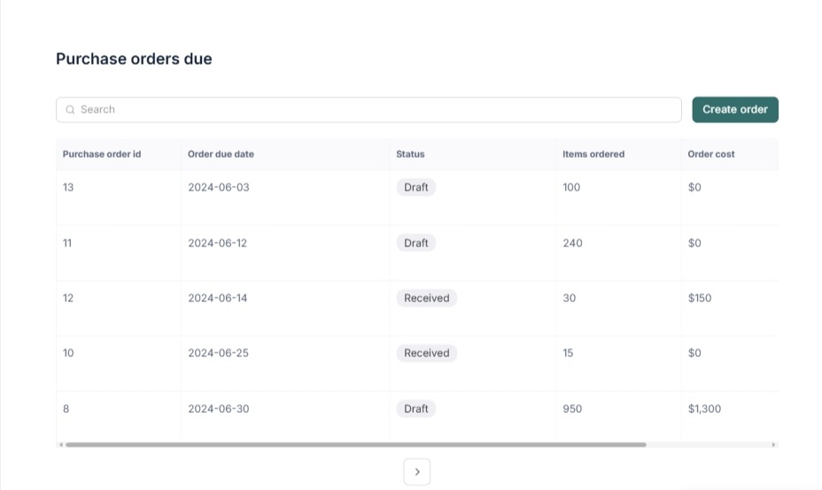

**3.5 Finance and Accounting**

This module will provide comprehensive financial management capabilities.

**General Ledger:**

The system will manage all financial transactions, ensuring accurate record-keeping and compliance with accounting standards.

**Accounts Payable/Receivable:**

Averx will be able to track money owed to suppliers and money owed by customers, facilitating effective cash flow management.

**Budgeting:**

Users will be able to plan and track expenses and revenues against budgeted amounts, enabling better financial forecasting.

**Financial Reporting**:

The module will generate essential financial documents, including balance sheets, profit and loss statements, and cash flow reports, providing insights into the company's financial health.

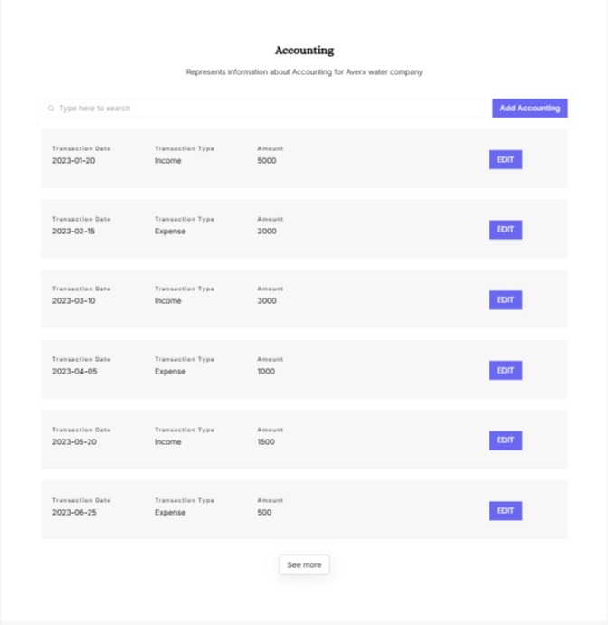

**3.6 Human Resources Management**

This module will streamline HR processes and improve employee management.

**Employee Database**:

The system will maintain detailed records of employee information, including roles, compensation, and performance metrics.

**Attendance Management:**

Averx will be able to track employee attendance, leaves, and work hours, ensuring accurate payroll processing.

**Payroll Processing**:

The system will automate payroll calculations based on attendance, overtime, and deductions, reducing the administrative burden on HR staff.

**Performance Management:**

This feature will allow for tracking employee performance and managing appraisal processes, fostering a culture of continuous improvement.

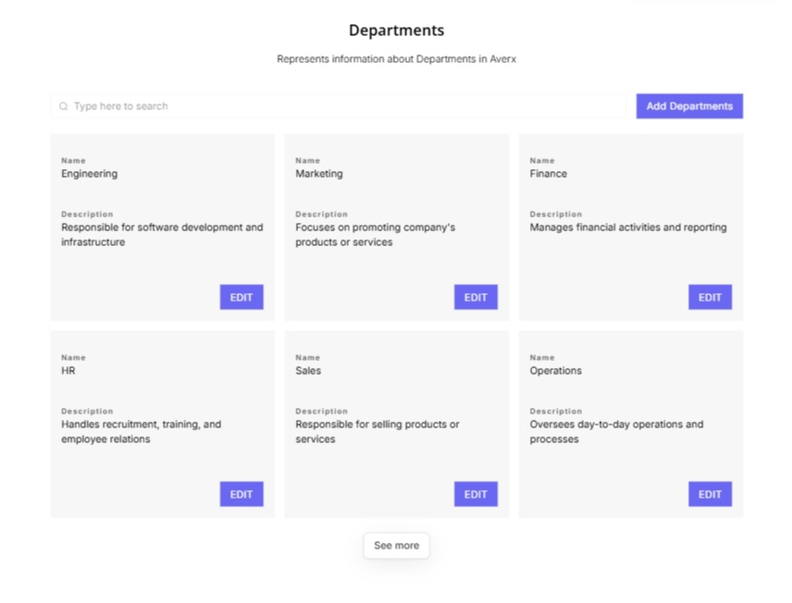

**3.7 Reporting and Analytics**

The Reporting and Analytics module will provide valuable insights into business performance.

**Dashboard**:

A visually appealing dashboard will display key performance indicators (KPIs) across all business functions, allowing for quick assessment of organizational health.

**Custom Reports**:

Users will have the ability to create tailored reports based on specific parameters, facilitating in-depth analysis of various business aspects.

**Data Export**:

The system will allow users to export data in formats such as CSV, Excel, and PDF for further analysis or reporting needs.

**Predictive Analytics**:

By leveraging historical data, the system will provide forecasts for inventory needs, sales trends, and financial outcomes, enabling proactive decision-making.

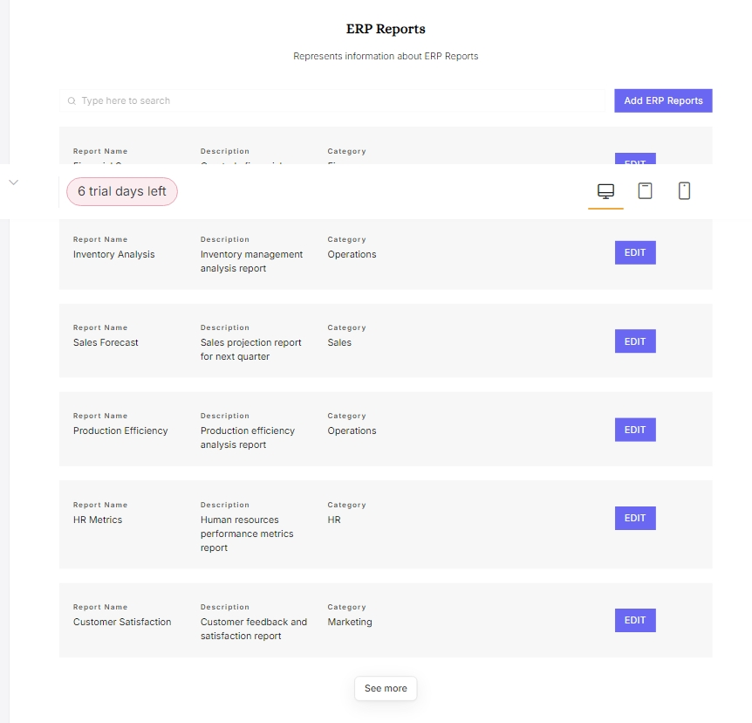

**4. User Interface Design**

**4.1 User-Friendly Interface**

The ERP system will feature an intuitive and user-friendly interface designed to accommodate users with varying levels of technical expertise.

**Navigation:**

A sidebar menu will provide easy access to different modules, while the home screen will feature a dashboard with key metrics for quick reference.

**Responsive Design:**

The interface will be fully responsive, ensuring usability across various devices, including desktops, tablets, and smartphones. This flexibility will enhance accessibility for users in different environments

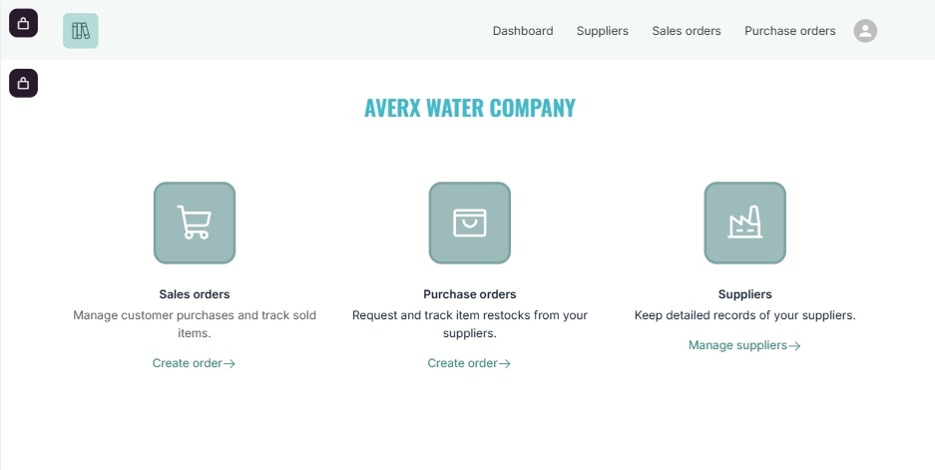

**Customization**:

Users will have the ability to customize their dashboards, allowing them to save personalized views that highlight the information most relevant to their roles.

**5. Conclusion**

The implementation of an ERP system for Averx is a strategic initiative that aims to enhance operational efficiency, streamline workflows, and support informed decision-making. By integrating key business functions into a cohesive system, Averx will be better positioned to respond to market demands, improve overall performance, and achieve sustainable growth in the competitive water manufacturing and distribution industry.